**Module 6 Assignment**

1. In Google Analytics, events are user interactions with your website or app that can be tracked and analyzed. They provide valuable insights into how users engage with your content beyond just page views and session duration. Events can be customized to track various types of interactions, such as button clicks, form submissions, video plays, file downloads, or any other action you want to monitor.

By tracking events, you can gain insights into user behavior, identify popular features or content, measure conversions, and optimize your website or app based on the data collected. Google Analytics provides reporting and visualization tools to analyze event data and make informed decisions about your digital strategy.

1. 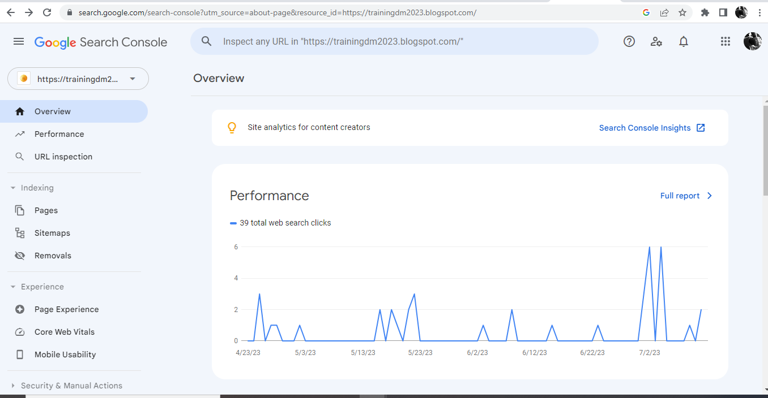

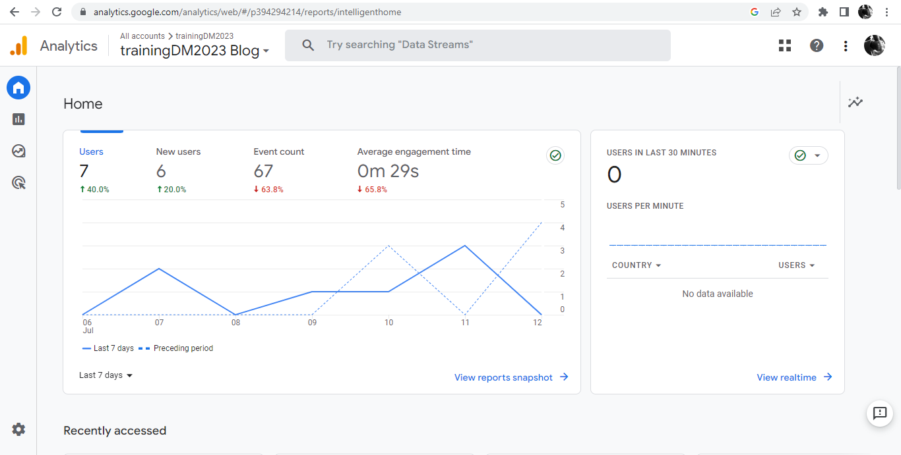

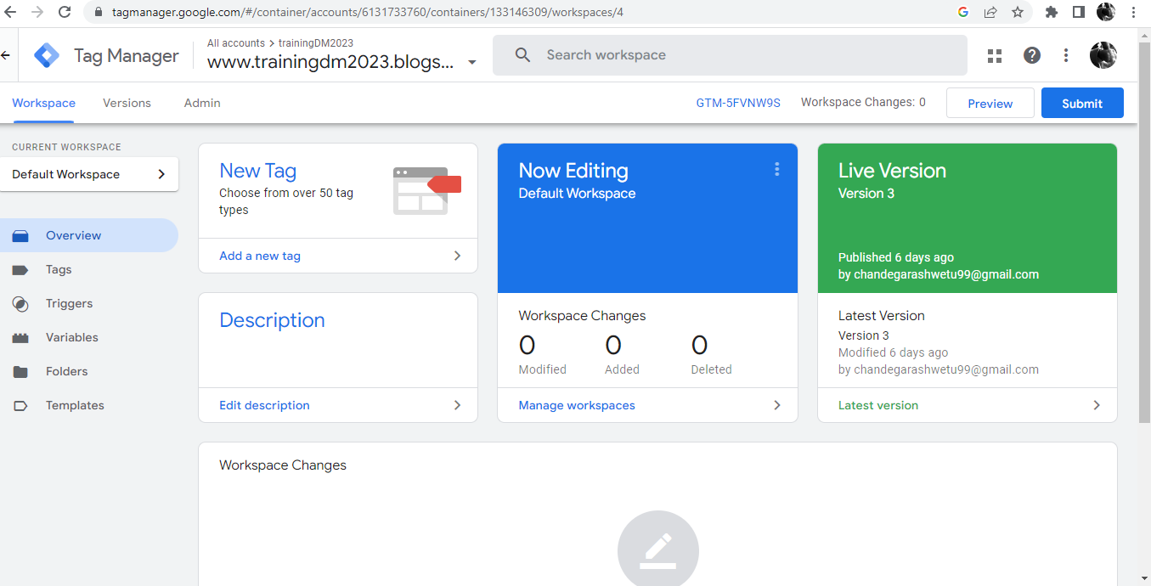

1. 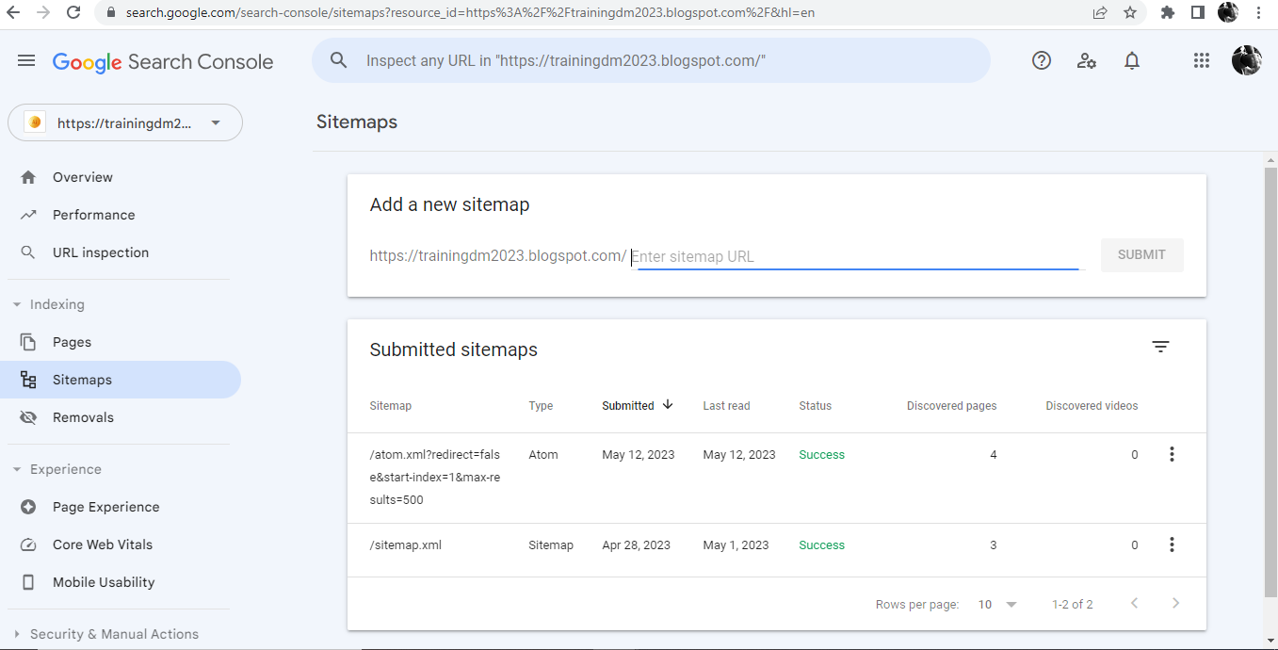
2. 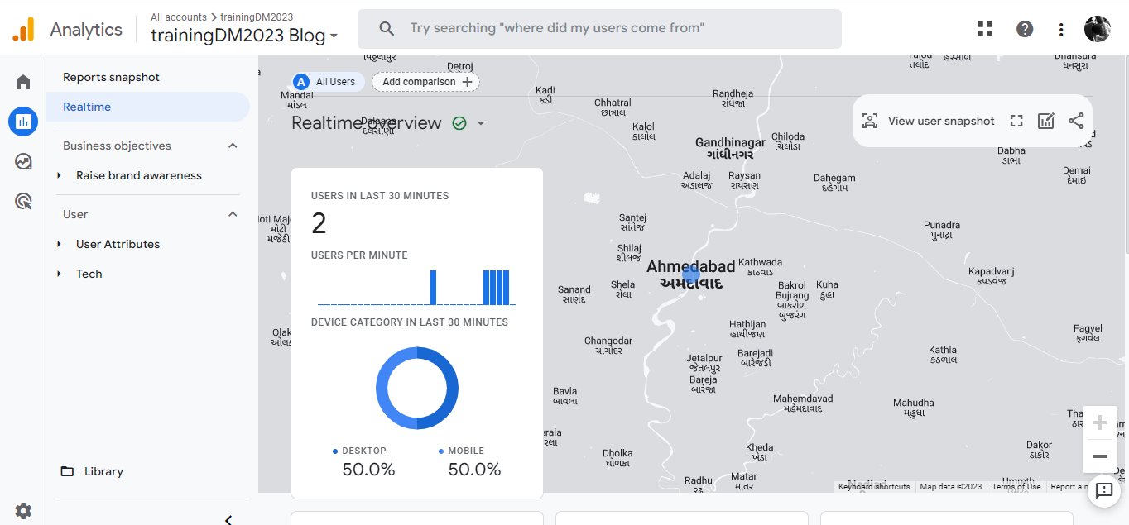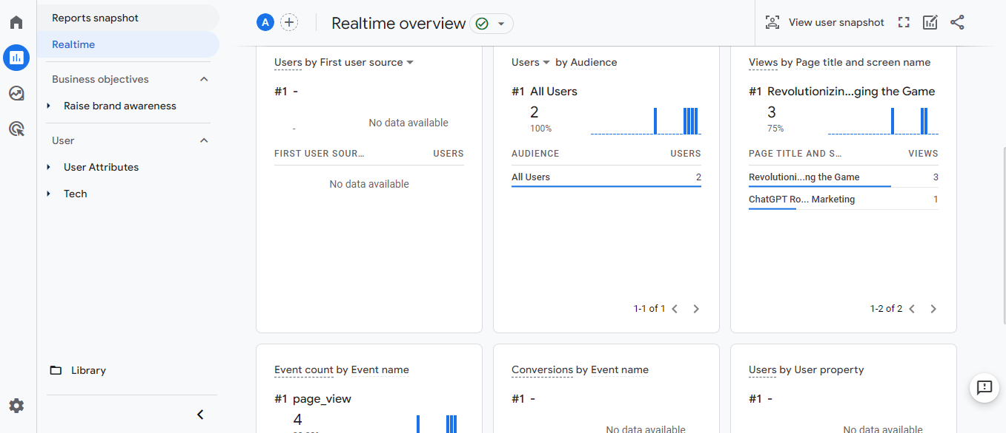
3. 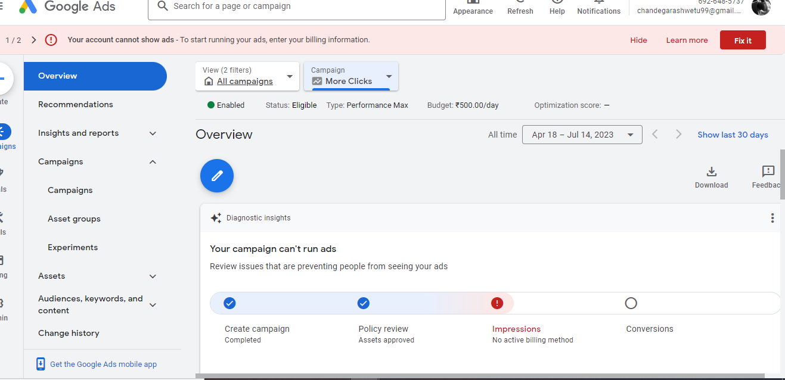
4. Here is my Blog site

<https://trainingdm2023.blogspot.com/>